Raspberry Pi Setup Documentation

Step 1: Make sure you have all the hardware required

Hardware (existing):

Microscope

Hardware to mount (3D print):

Hardware (to buy):

1. Raspberry Pi 4 Model B
2. Raspberry Pi case (with open section)
3. Raspberry Pi charger
4. Raspberry Pi camera
5. Raspberry Pi fan
6. Raspberry Pi heatsink
7. Raspberry Pi HDMI adapter
8. MicroSD card (at least 8GB)

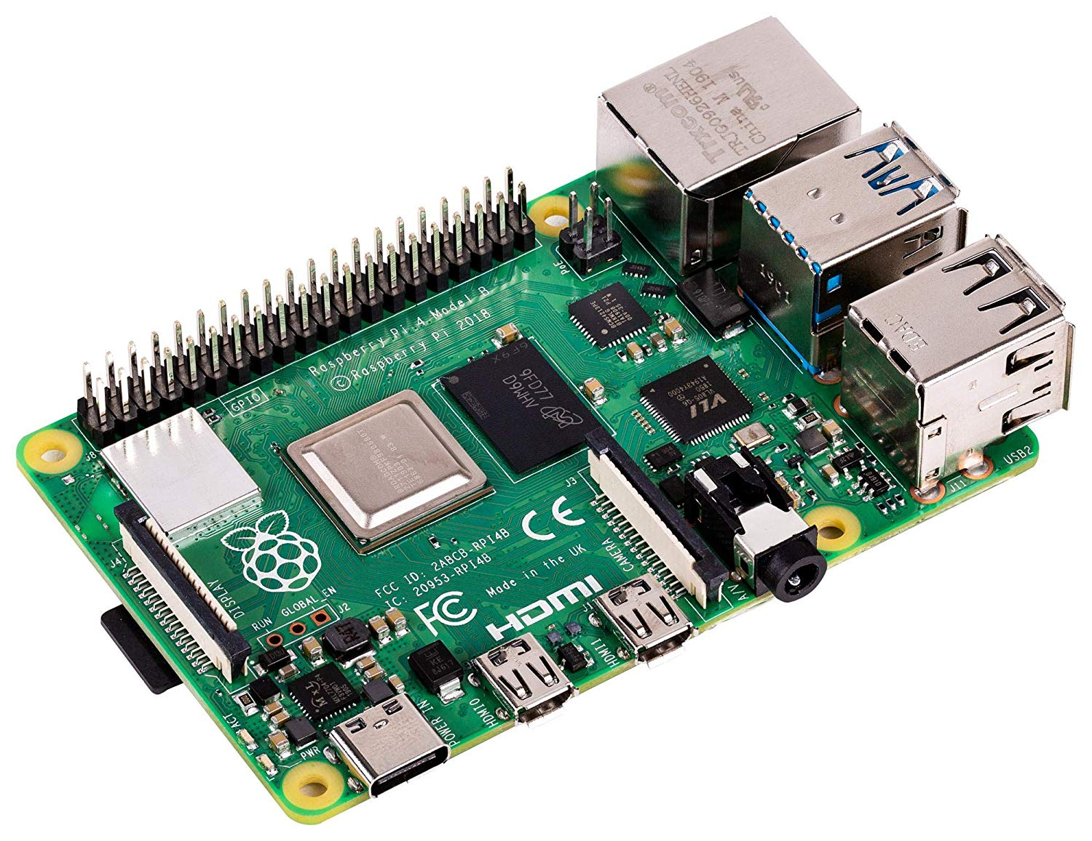

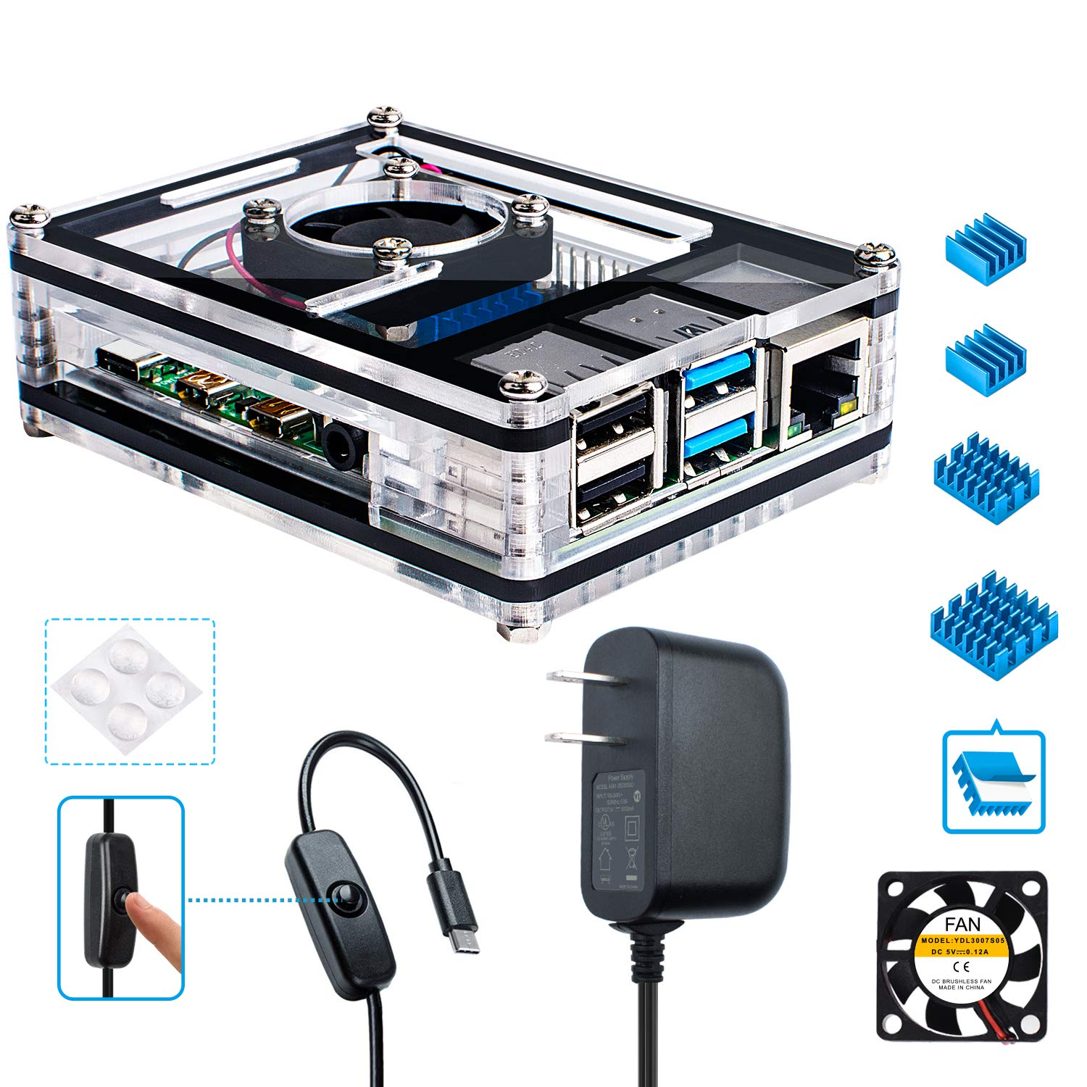

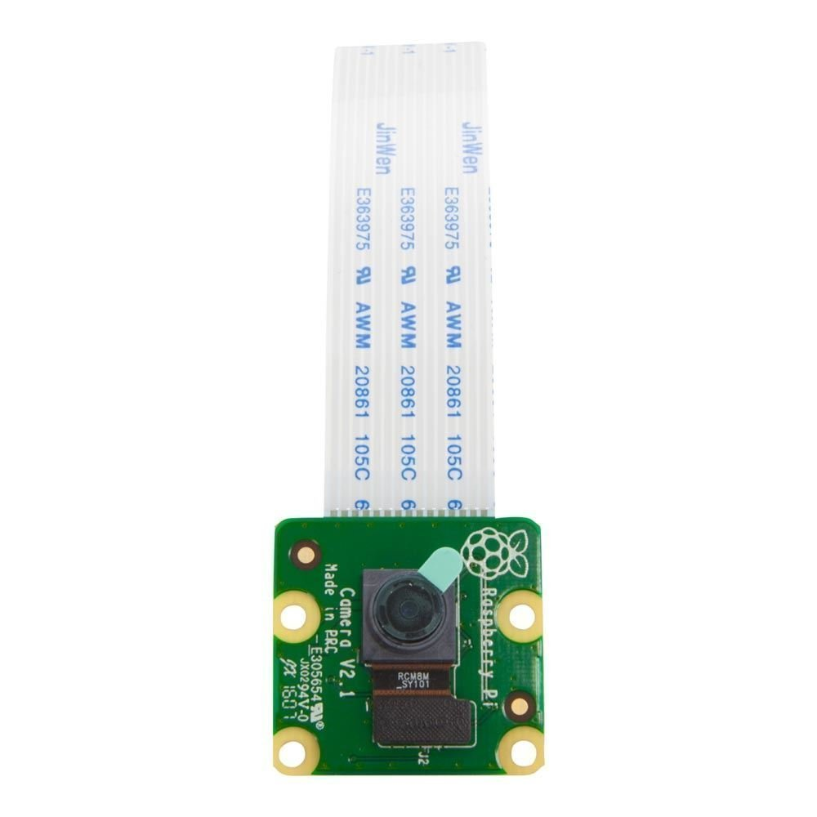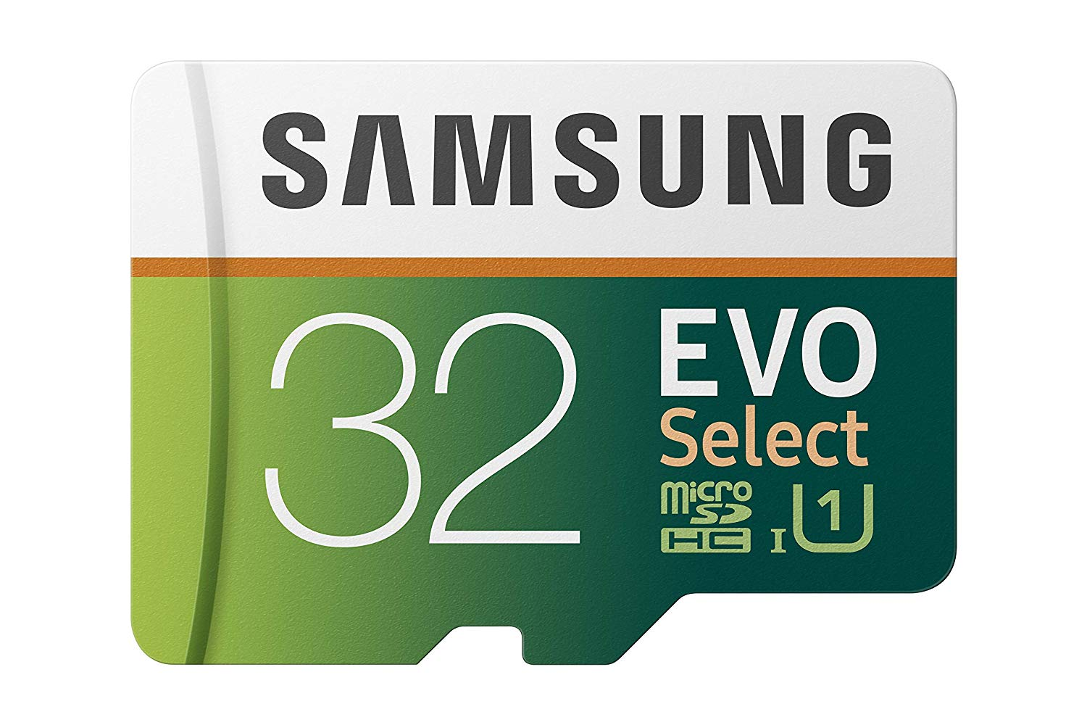

YOUTUBE LINK

Set up Youtube Account

• Create a Youtube account on http://youtube.com.

• Log into your YouTube account.

• Go to the Creator Studio page.

• Open the Features section.

• Scroll down the Features panel and click "Enable.

• Verify your identity.

• Accept the terms and conditions.

• Set the details of your live stream.

• Click the "Go Live Now" button on the lower right corner of the page.

• This will allow you to live stream on your channel but it will take 24 hours to activate.

• Once the activation as been approved, log into your Youtube account to grab your Youtube RTMP Stream Link which will be copied and pasted into the Admin Panel> Microscope of choice Edit section.

• Click your User Profile Icon.

• Click on the Youtube Studio button.

• Click on Creator Studio Classic on the left side panel.

• Click skip.

• On the left side panel, find and click on the Live Streaming tab.

• Scroll down to the bottom and find the Encoder Setup section.

• Copy the ServerURL (example: rtmp://a.rtmp.youtube.com/live2).

• Press the Reveal button and copy the stream/key.

• Add the stream name to the end of serverUrl with an extra slash /.

Example: rtmp://a.rtmp.youtube.com/live2/woisufoisuoflsdjfl

Step 2: Setting up the microSD card

This step will install the operating system Noobs into the microSD card so it can be used in the Raspberry Pi.

1. Open microSD card and insert into computer.
2. Go to <https://www.raspberrypi.org/downloads/noobs/> and download Noobs zip file.
3. Go to <https://www.raspberrypi.org/help/noobs-setup/2/> and follow the directions.
   1. When download is finished extract the files from the zip.
   2. Go to <https://www.sdcard.org/downloads/formatter/> and download the SD Formatter 4.0 for either Windows/Mac.
   3. Install SD Formatter 4.0 and then run it.
   4. In SD Formatter 4.0, format microSD card.
   5. Move the extracted Noobs files into the now formatted microSD card. You need to have the files inside the Noobs folder inside the microSD card, NOT
   6. Remove microSD card safely.
4. Remove microSD card safely.

Step 3: Setting up Raspberry Pi and its corresponding hardware

1. Insert microSD card into Rasberry Pi slot and set aside.
2. Follow the instructions of the Raspberry Pi case (included with the case).
   1. Before closing the top/lid attach the Raspberry Pi, feed the camera strip through the slot and connect it to the Pi. When connecting the camera, lift the black strip of insert on the pi device, insert strip, then secure black strip.
3. Remove film on camera.
4. Attached Micro HDMI adapter to HDMI cord connected to a display monitor.
5. Insert the HDMI micro adapter end to the micro slot on the raspberry pi.
6. Insert the power chord into the power slot on the raspberry pi.
7. Once completed, you will see your monitor populate a message pop up window.

Step 4: Setting Raspberry Pi Operating System

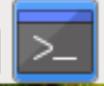1.Click install for Noobs. (This could take awhile).

2. After installation is complete you will see a message that will say “OS(es) installed successfully” then click OK..

3. The raspberry pi will restart

4. see gallery picture to complete this section

• You will see a welcome message pop up window. Click Next.

• Set country window will populate. Set country, language, timezone to your location. Check “Use English language” and check “Use US keyboard. Press Next.

• The Change Password window will populate. Set new password. Click next.

• The Set up screen window will populate. Check the “This screen shows a black border around the desktop. Click Next.

• The Select Wifi Network window will popluate. Click Skip.

• The Update Software window will popluate. Click Skip.

• The Setup complete window will poplate. Click Restart.

Enable camera

* Go click on the raspberry on the top left corner. From the drop down select preferences, then go to the Raspberry Pi Configuration. Go to Interfaces tab, then click Enable in camera. You will be prompted to restart, click yes.

PLACEHOLDER : Setting up Eduroam Configuration

1. Open up a terminal by clicking on the following symbol in the tool bar.

2. Add in wifi credentials by typin in the following: sudo nano ../../etc/wpa_supplicant/wpa_supplicant.conf

3. Type in the following and fill in your credentials where the fields are “”

4. Press control + o to save

5. Press control + x to close the file.

6. Kill the process that is currently running

7. Type in ps aux | grep supplicant to find the process number to kill

8. The number we would like to kill has something like this in the message

9. type in Kill plus the number

10. type in

Step 5: Setup Internet Connection

Step 6: Update, upgrade, and install the necessary connecting software

1. Go to the terminal
2. Install ffmpeg (software that allows video streaming) by typing in: “sudo apt get install ffmpeg” and hit the enter key
3. Install the update for the Noobs operating system by typing in: “sudo apt-get update” and hit the enter key
4. Install the upgrade for the Noobs operating system by typing in: “sudo apt-get upgrade” and hit the enter key. If there is a prompt to ask if you want to continue, select yes. There were be multiple preparing and unpacking. Some packages present a log of their changes, if a prompt appears asking if you want to quit, press q. (google linux change log, press q to quit for photo). An information window will show up saying that upgrade has been installed.
5. To connect to the database you install a Mysql connector type: “sudo pip install mysql-connector-python==8.0.11” and hit enter
6. You want to download the virtualscope python file and saving it to your raspberry pi. To do this type: “wget -O virtualscope.py <https://raw.githubusercontent.com/huntress13/TeamPuma-VirtualScope/master/Raspberry/virtualscope.py>” and press enter. you should get a message in the terminal that infers that the file virtualscope.py has been saved
7. Type the letters “ls” to show what is in your files by command line. You should see the file you just downloaded virtualscope.py

Make sure that you are in home/pi/MicroscopeImages/

* You want to create a folder to put in the streaming photos. To do this you need to make a folder. Make a new folder/directory by typing “mkdir MicroscopeImages” and press enter.

Get livestream to work

To run the python file type: “sudo python virtualscope.py microscopeName” (microcscopeName is the name of your microscope. That is the only word in the command that should change. After you click enter, you should immediately be streaming and picture taking. To take a photo, the camera stops streaming, takes a photo, then goes back to stream.

Put everything together:

* Turn on the microscope and put in a subject slide
* focus the slide to what you want
* Fit the hardware pieces to the camera
* Turn on the raspberry pi
* Mount the camera piece to the eyepiece.